How to enable Message Module to your B2B?

- Open your SANAPI and active the below parameter :
ReservationSettings.ShowComment
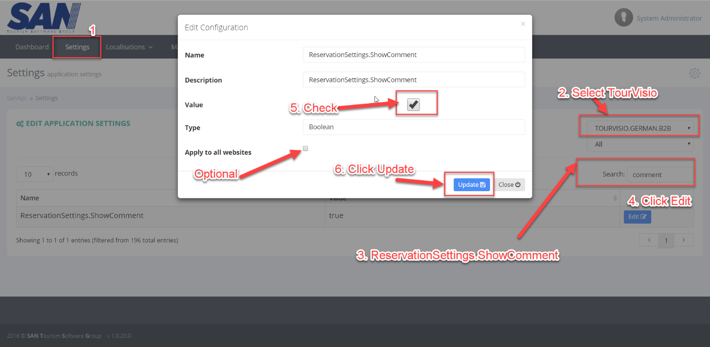

- Open your B2B: After Finish a Reservation; A message button will be appearing in your B2B as below:
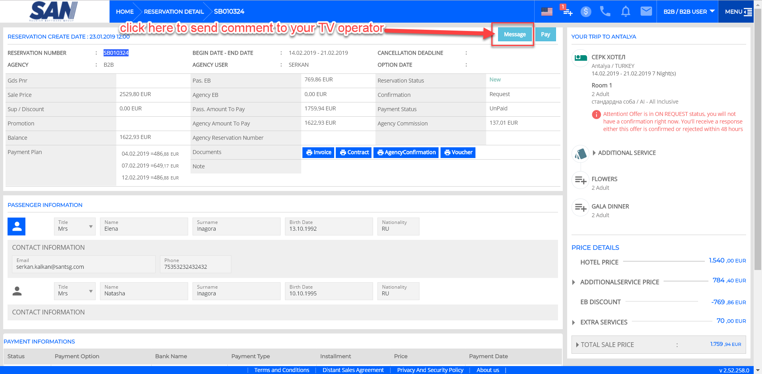

- Click on Message Button
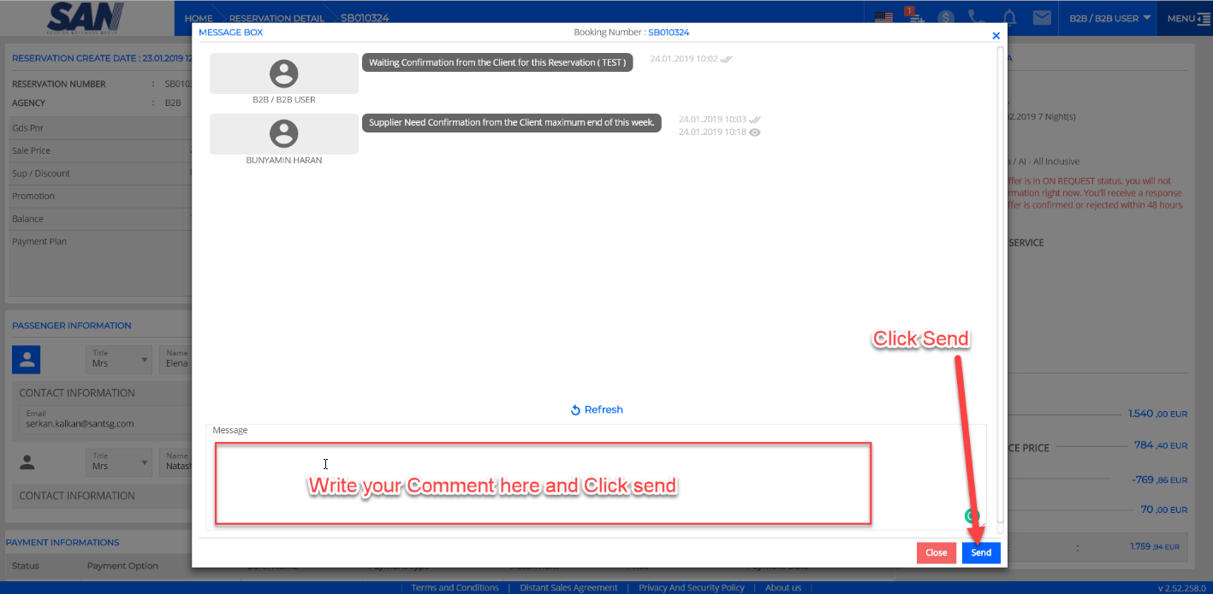

- In TourVisio
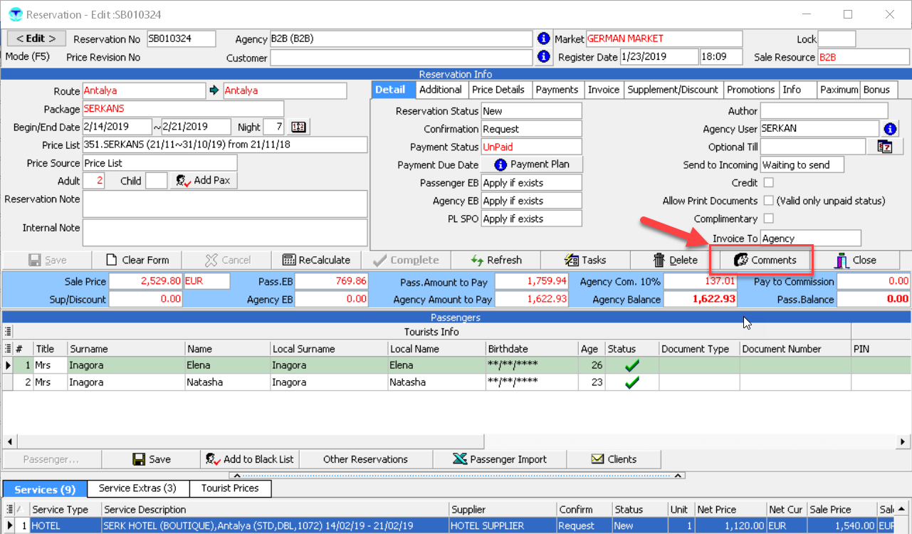

- Click Comment in TV
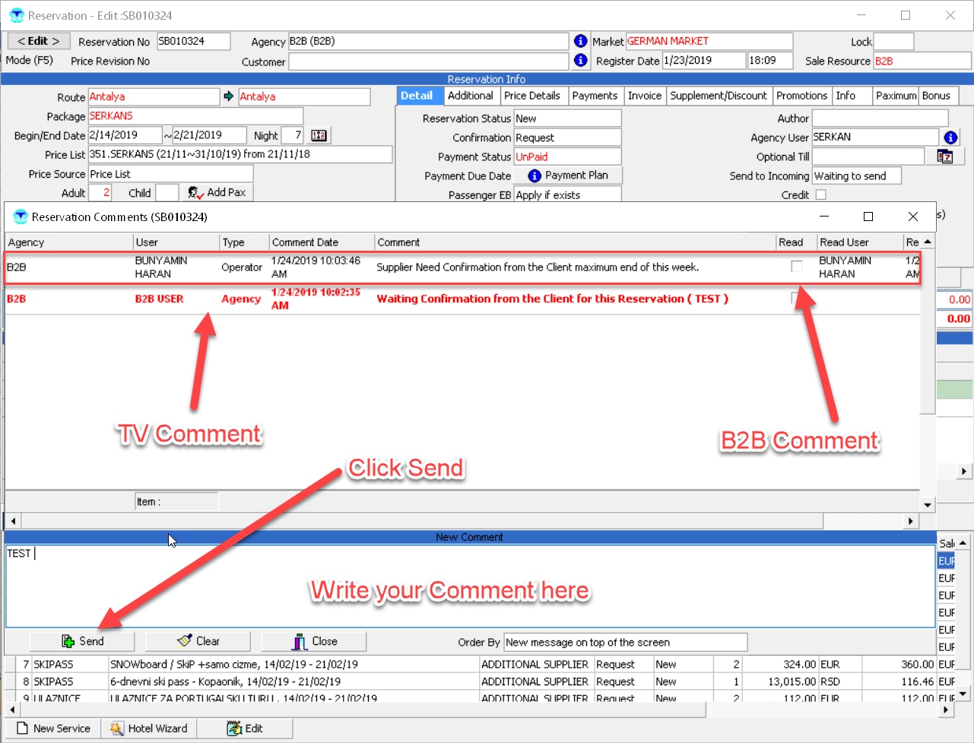

- After Sending Comment from TV; once your will open your B2B you will get notification of a new Comment as below:
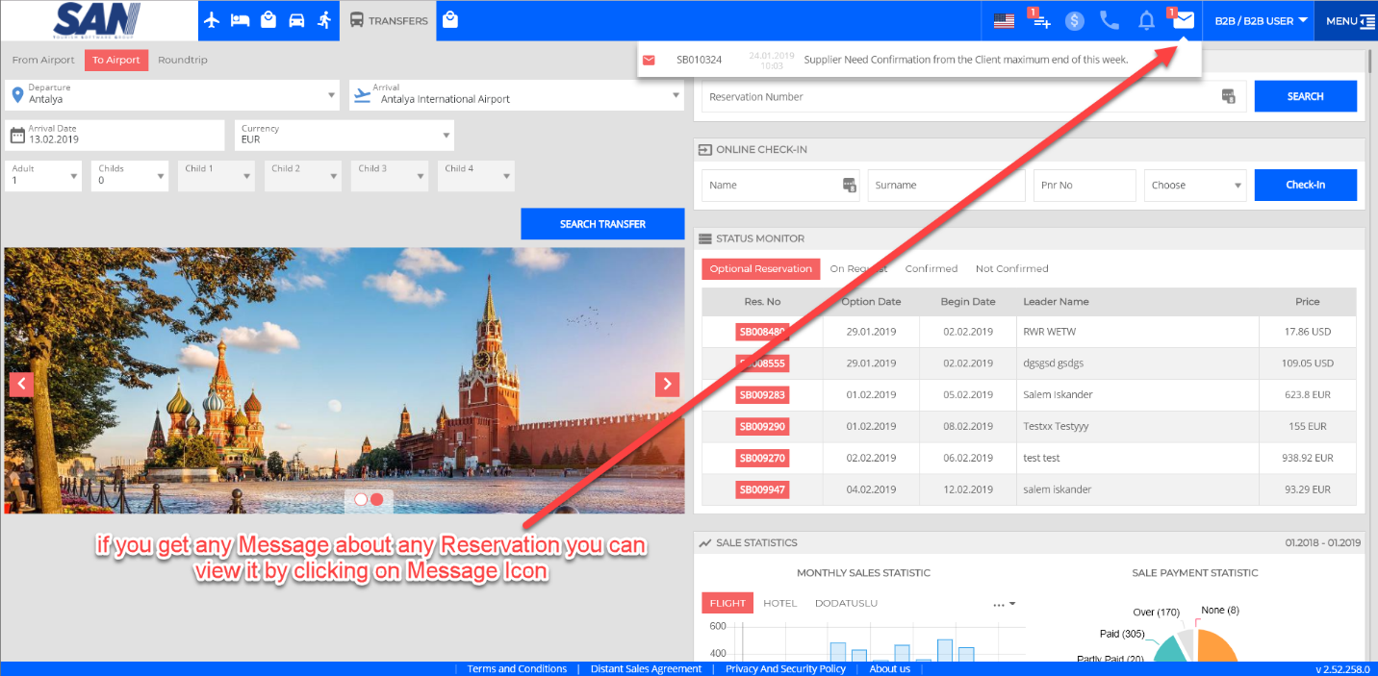

- Click on the message
