Only Hotels Sales
From now on you will have possibility to publish “only hotel” prices without creating any package or price list. For using this new TourVisio technology you have to do some configuration which we’ll show you on the screenshots below:
- Under Definition / Hotels you have to edit your Hotel which you want to activate for
“Only Hotels Sales”. Under the tab Parameters you have to activate the click
“Allow only hotel sales”.
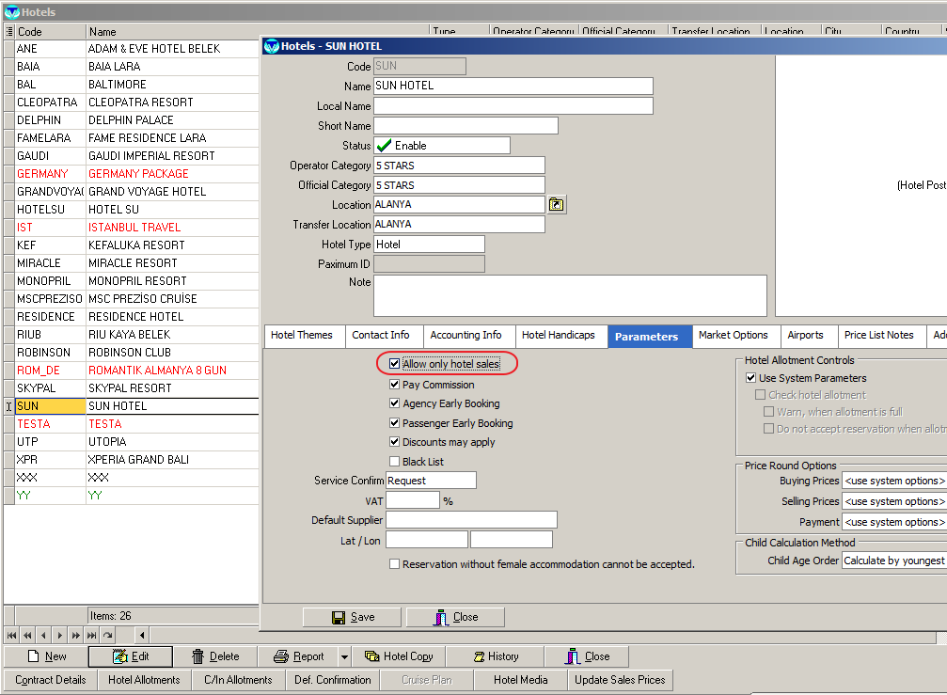
- The second step is to activate your hotel contract for “Only Hotels Sales”. For this step please edit your Hotel Contract and activate the click “Allow only hotel sales”.
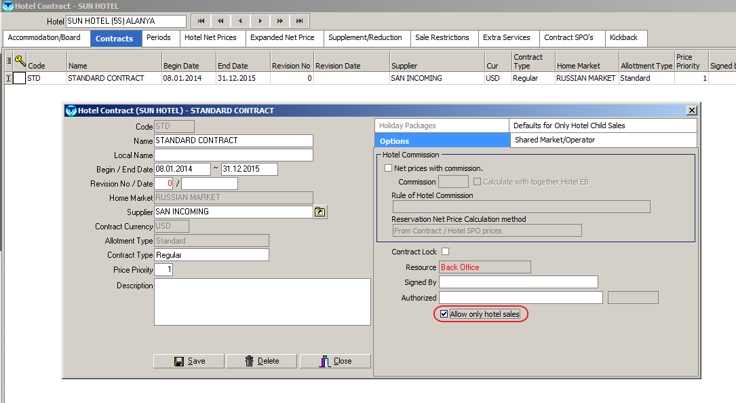

- Now you have to define Child Age Groups and child prices in percentage according to the adult prices. For this you have to click tab “Defaults for Only Hotel Child Sales” and there you should insert Child Age Group combinations and child prices in the percentage according to adult price.
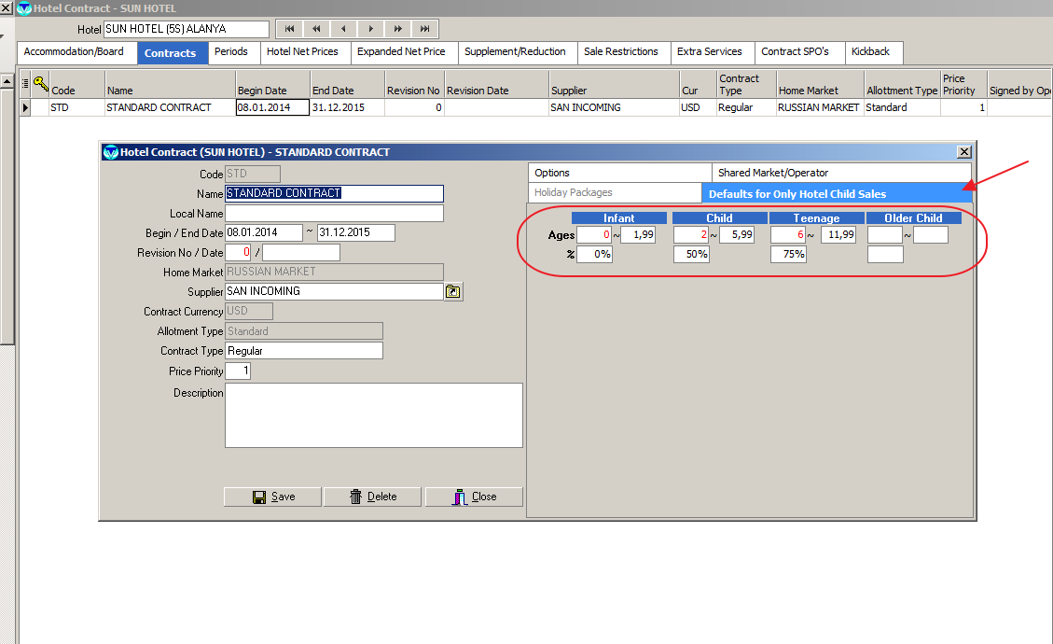
- You have also possibility to adjust the child Age Groups and child prices in percentage according to the adult prices day by day. For that you have to edit your Prices and click tab “Child Sale Price for Only Hotel Child Sales”
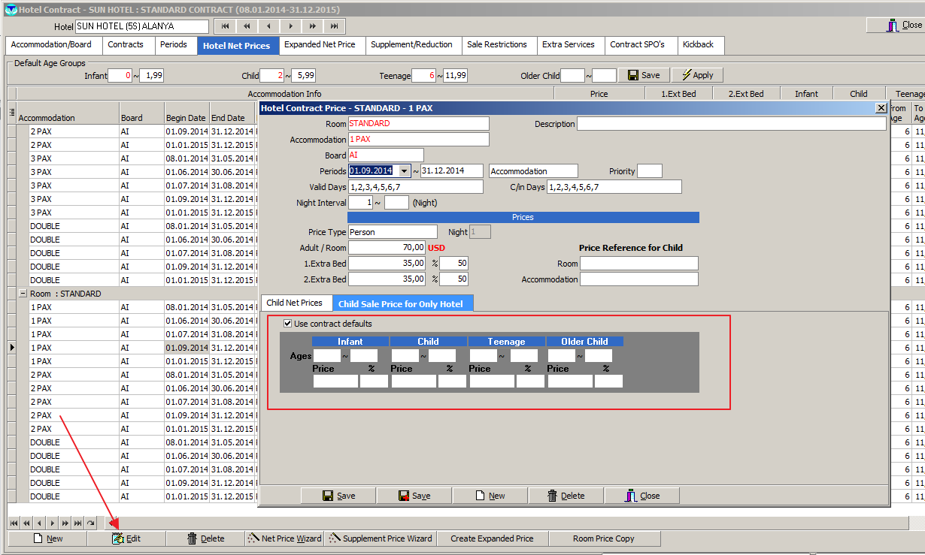

- Your next step is now to define the profit rules for your “Only Hotels Sales”. For this you have to go to “General Profit Margin” and click the tab “Hotel Sale”. There you can define profit Hotel by Hotel or generally for All Hotels at the same time.
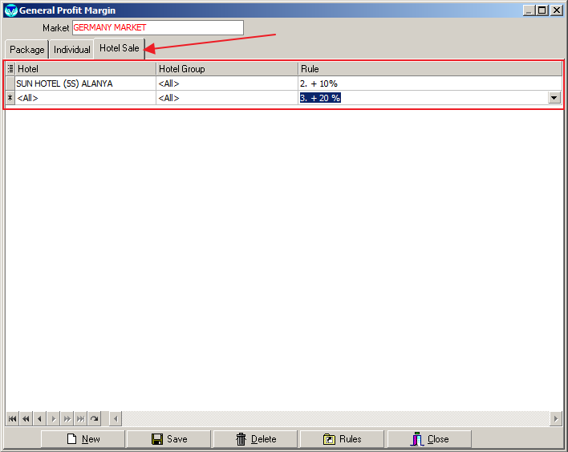
- For activating your hotels to the sale you can start a manual “Update Sale Price” process hotel by hotel under Definition / Hotels or you can activate a TVCC (TourVisio ControlCenter) task which starts the process automatically with intervals.
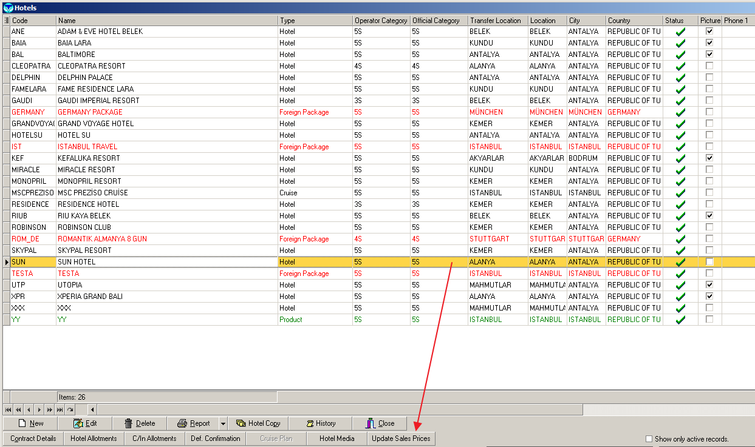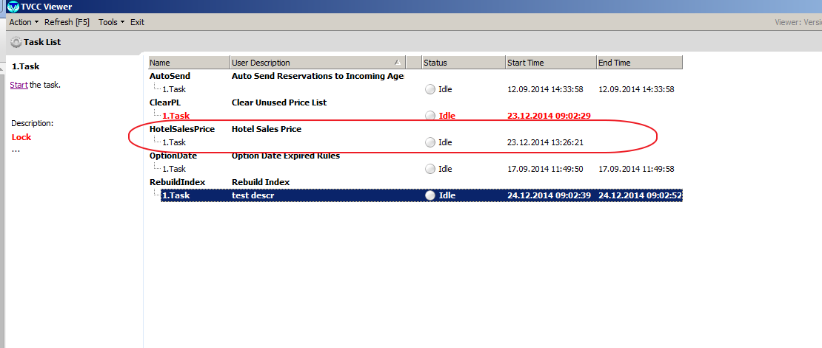

- Also you can update your Hotel SPO’s manually one by one or wait until your TVCC will update your Hotel SPO prices.
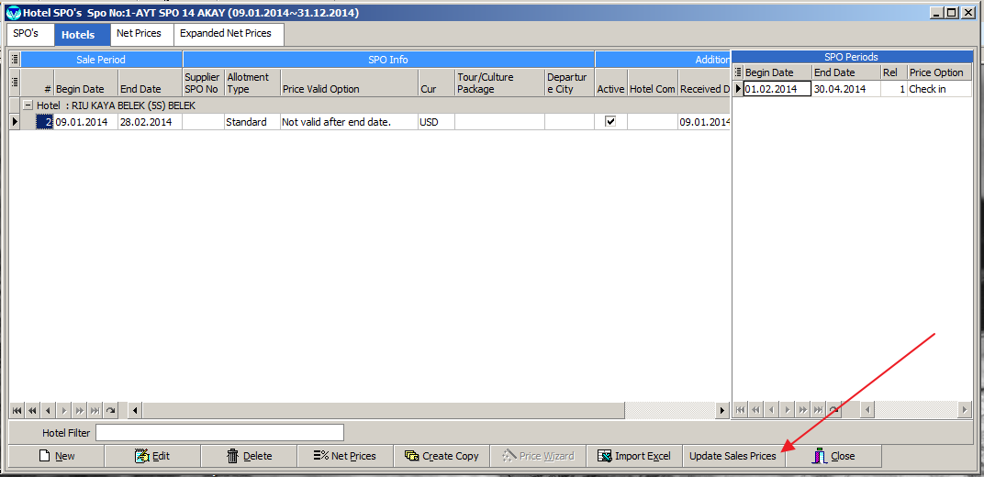
- Finally you can do reservations by using the Price Search Wizard. For making reservations you have to use tab “Only Hotels”. Your prices for B2B or B2C will be automatically updated after the updating process is successfully.
